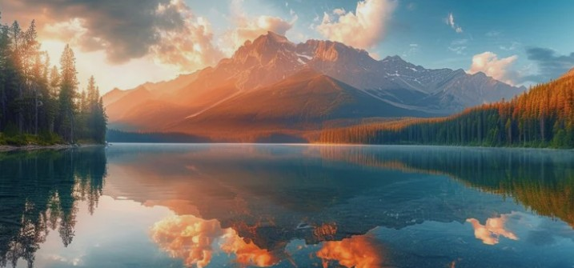
Accommodations
Your Getaway Awaits
Check-in  MM/DD/YYY | Check-out  MM/DD/YYYY | Guests  2 Guest | Search

Home
Activities
Dining & More
About Us
MOFFAT BAY LODGE

Cozy Rooms  Comfortable lodge rooms with  stunning views | Outdoor Activities  Hiking, kayaking, whale  watching & more | Dining & More  Delicious local cuisine  & drinks
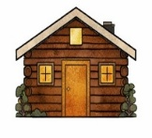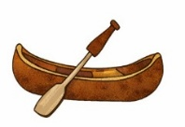

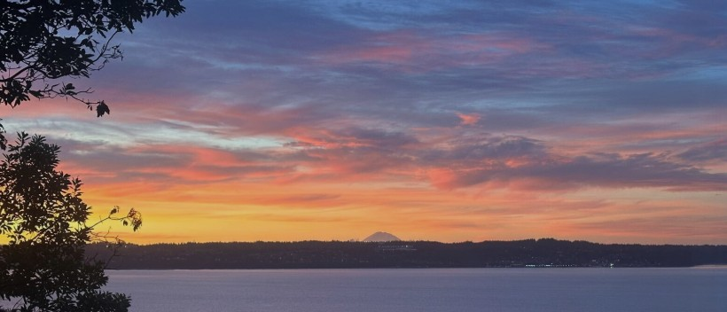

Discover Moffat Bay
Experience the beauty and adventure of Moffat Bay Lodge.
Perfect for a romantic escape or a family vacation.

Contact Us

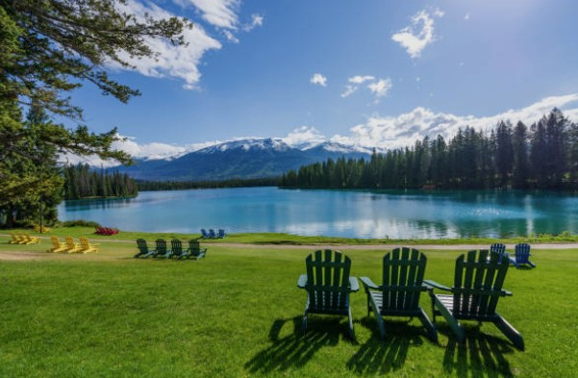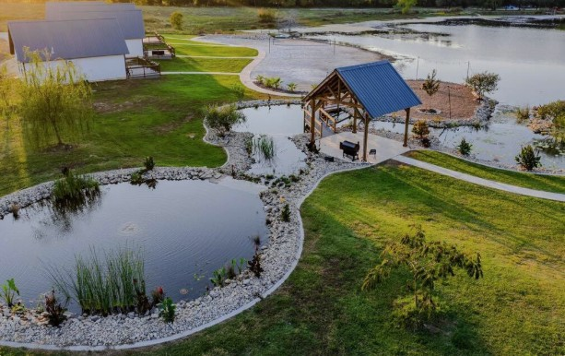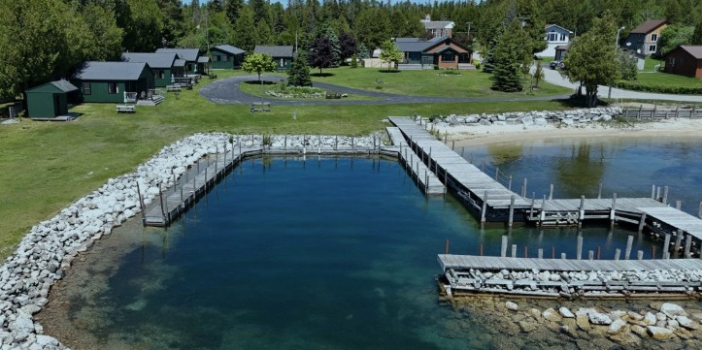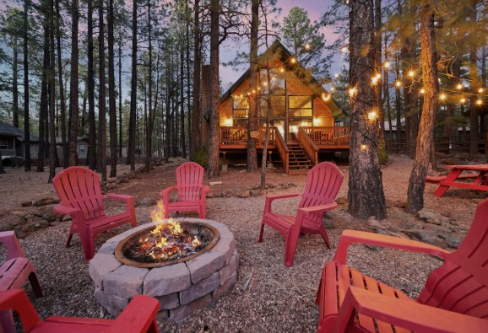
Ready to Book Your Stay?

VIEW ROOMS
LOG IN
or

